VIETNAM NATIONAL UNIVERSITY OF HOCHIMINH CITY

THE INTERNATIONAL UNIVERSITY

SCHOOL OF COMPUTER SCIENCE AND ENGINEERING



**SMART HOME**

A thesis submitted to the School of Computer Science and Engineering

in partial fulfillment of the requirements for the degree of

Bachelor of Information Technology/Computer Science/Computer Engineering

Ho Chi Minh City, Vietnam

Year 2022-2023

**SMART HOME**

**ADVISOR:**

Assoc. Prof. Lê Duy Tân

**TEAM MEMBER:**

Le Thanh Phuong Nam – ITITWE19025

Đặng Khải Dương – ITITWE19010

Đinh Bình Thanh Thông – ITITWE19027

THESIS COMMITTEE

(Whichever applies)

# 

# **Contribution**

|  |  |  |  |
| --- | --- | --- | --- |
| **Name** | Lê Thanh Phương Nam | Đặng Khải Dương | Đinh Bình Thanh Thông |
| **Percent** | 1/3 | 1/3 | 1/3 |

# **ACKNOWLEGMENTS**

First and foremost, we would like to express our heartfelt appreciation to Dr.Le Duy Tan, the subject lecturer, for always staying in touch for any problems, teaching and imparting valuable knowledge to me during my study period,. While taking the Computer Network course, we gained a lot of useful knowledge and effective learning skills. Computer networking is a interesting, practical, and useful subject. Despite our best efforts, the essay contains numerous errors and inaccuracies. We hope you will review our essay and make suggestions to improve it.

# **Table of Contents**

**Contribution** 2

**ACKNOWLEGMENTS** 3

**Table of Contents** 4

**LIST OF FIGURES** 6

**LIST OF TABLES** 7

**ABSTRACT** 8

**Chapter 1: Project Description** 9

**1.1.** **Project Overview** 9

**1.2.** **The Purpose of the Project** 9

**1.3.** **Scope of Work** 9

**1.4. Organization** 10

**1.5. Resource Requirements** 11

**1.6. Schedule** 14

**1.7. Risk Management** 18

**1.8. Conclusion** 19

**Chapter 2: Requirements** 20

**2.1. Product Use Cases.** 20

**2.2.** **Functional Requirements** 27

**2.3. Data Requirements** 28

**2.4. Performance Requirements** 29

**2.5. System Requirements** 29

**2.6. Security Requirements** 29

**2.7. Usability Requirements** 30

**Chapter 3: Design** 31

**3.1.**  **System Architecture** 31

**3.2. Database Structure** 32

**3.3. Class Diagram** 33

**3.4. Database Design Diagram** 34

**3.5. Sequence Diagram** 35

**CHAPTER 4: METHODOLOGY** 36

**4.1. Overview** 36

**4.2. Technology** 36

**4.3. Algorithm** 36

**4.4. User Interface Design** 38

**REFERENCES** 39

**APPENDIX** 41

# **LIST OF FIGURES**

Figure 1. Trello Management 11

Figure 2. Gantt Chart 14

Figure 3. Work Breakout Structure 15

Figure 4. Use Case Diagram 20

Figure 5. UML Class Diagram 28

Figure 6. ERD Diagram 28

Figure 7. System Architecture 31

Figure 8. MVC Diagram 32

Figure 9. Database Structure 32

Figure 10. Class Diagram 33

Figure 11. Database Design Diagram 34

Figure 12. Sequence Diagram 35

Figure 13. UI/UX Design 38

# **LIST OF TABLES**

Table 1. Supplier 10

Table 2. Project Organization 10

Table 3. Hardware Resource 11

Table 4. Software Resource 12

Table 5. Human Resource 13

Table 6. Product Backlog 17

Table 7. Risk Requirement 19

Table 8. Use Case 1 21

Table 9. Use Case 2 21

Table 10. . Use Case 3 22

Table 11. Use Case 4 22

Table 12. Use Case 5 23

Table 13. Use Case 6 23

Table 14. Use Case 7 23

Table 15. Use Case 8 24

Table 16. Use Case 9 24

Table 17. Use Case 10 25

Table 18. Use Case 11 25

Table 19. Use Case 12 25

Table 20. Use Case 13 26

Table 21. Use Case 14 26

Table 22. Functional Requirements 28

Table 23. Appendix 41

## **ABSTRACT**

**Researching Group: MU Glory**

**Presentation Title: Using A.I voice to control Smart Home**

**Research focus: Technology & Algorithm**

**School: HCM International University**

**Level: Students**

**Presentation Type: Pre-thesis Document**

In the 4.0 revolution, people are becoming more and more in need of modernizing and civilizing their way of life and living conditions. Since that time, smart home technology has represented the transition of people to a higher-tech way of living. Currently, the module has both large and small applications due to the growth of smart home technology. Our project also aims to aid in the modernization and efficiency-improving of already existing systems.

Our research indicates that while Smart home A. I voice technologies have advanced significantly based on a computer network system combined with popular AI algorithms; however, they have not yet realized their full potential because there are still occasional system faults that result in noise or incorrectly received by the receiver and carry automatically out actions without being asked. Or if the technology simultaneously misrepresents the needs of the user. Since then, our project has been developed to optimize and solve the issues mentioned above.

## **Chapter 1: Project Description**

### **Project Overview**

The devices in a smart home are connected by the internet, allowing users to control features like temperature, lighting, security access, and home entertainment systems from a distance. Door locks, televisions, thermostats, home monitors, cameras, lights, and even appliances like the refrigerator may all be controlled by a single home automation system. The system, which is installed on a mobile device or other networked device, allows the user to specify the times at which particular changes should take effect.

### **The Purpose of the Project**

The initial goal of the project was to create a website or mobile application that would address some utility needs in the user's house. Applying new technological sources following our capabilities. At the same time, develop algorithms and methods to get around the shortcomings of the current Smart Home technology available on the market, such as A. I's malfunctions, issues of poor sound reception, A. I's inability to filter noise and conduct tasks automatically fully,...

As the result, we decided to create a Smart Home technology that can be used on smartphones to perform domestic conveniences, and at the same time, we'll employ technology to scan user sound and noise filtering the sound that impacts the system to ensure users' requirements effectively.

### **Scope of Work**

We employed a variety of technologies for this project to manage, organize, and store the data, design the deployment application, and build the platform for developing, distributing, and running the program. As a result, the graduation project our team will provide customers with a more authentic experience.  
Applying specialist expertise gained from previous projects is important, but so is acquiring knowledge from independent research to finish the project. At the moment, this project exclusively uses mobile applications and deploys all protocols. There are two distinct account kinds. The user's account will be supported by a technical and service provider to register and install the application at home. The other is controlled by high-level departments that manage data on users of the service who look up information to fix mistakes or advance technology in the future.  
Customers can use the application instead of a walkie-talkie to command the system to perform indoor tasks anywhere there is an internet connection by voice or virtual required button, including Turning on/off the lights in the rooms of the house, and turning on/off. fans, air conditioners, televisions, and speakers and answer critical questions for users with A. I google keywords.  
Our concept still has a lot of limitations, though, because there isn't enough money coming from investors to allow us to directly apply technology to a real house. Therefore, we only intend to execute this project using homemade tiny models with more economical scale.

### **1.4. Organization**

#### **1.4.1. Organizational Boundaries and Interfaces**

There will only be one for the project manager. It is his responsibility to gather the work and distribute it to the team members during weekly meetings. We evenly distribute the leadership roles in our group each week. which means that someone must research this week's workload and present it to the team before someone else is informed the following week. This keeps high and low contributors from receiving the same grade and guarantees that each member can decide fairly and comprehend the progress of the project.

|  |  |
| --- | --- |
| **Company (Contact)** | **Deliverable** |
| Dr. Duy Tân Lê | User's information for testing application Policy for application |

Table 1. Supplier

#### **1.4.2. Project Organization**

|  |  |
| --- | --- |
| **Task** | **Name** |
| Project Manager | Le Thanh Phuong Nam |
| Desginer | Dang Khai Duong |
| Business Analyst | Dinh Binh Thanh Thong |

Table 2. Project Organization

Figure 1. Trello Management

### **1.5. Resource Requirements**

#### **1.5.1. Hardware**

|  |  |  |
| --- | --- | --- |
| **Item** | **Quantity** | **Purpose** |
| Laptop Lenovo Legon Y520 | 1 | Implement Code |
| Destop Computer | 1 | Implement Code |
| MacBook Pro 2017 | 1 | Implement Code |
| Arduino | 2 | Create Interactive Electronic objects |
| Esp32 | 1 | Create Interactive Electronic objects |
| Bluetooth Stereo JBL J3 | 1 | Connect to Sound |
| TV Samsung Smart HUB | 1 | Connect to TV |
| Camera Dome DS -2CD1123G0E | 1 | Connect to Camera |

Table 3. Hardware Resource

#### **1.5.2. Software**

|  |  |  |  |
| --- | --- | --- | --- |
| **Applicaton** | **Quantity** | **Description** | **Purpose** |
| Visual Studio Code | 3 | An integrated development environment for OS. Debug, syntax highlights, completion of the intelligent code, fragments, code refactoring and built-in git are just some of the available functions. | Implement Code |
| MySQL | 3 | An open-source relational database management system (RDBMS) | Storing data |
| Microsoft Teams | 3 | A collaboration application | Meeting, reminding, and storing files Meeting, reminding, and storing files |
| Trello | 3 | The visual tool that empowers your team to manage any type of project, workflow, or task tracking. | Manage thhe Project |
| Git | 3 | Web for sharing and uploading code | Managng Code |

Table 4. Software Resource

#### **1.5.3. Human**

|  |  |  |  |  |
| --- | --- | --- | --- | --- |
| **Name** | **Organiztion** | **Role** | **Required Skiil** | **Contact** |
| Le Thanh Phuong Nam | International University | Project Management, Sofware Engineer | **Technical skill:**  Basic understanding of OOP, OOAD, programming languages, and database structure. | **ITITWE19025@student.hcmiu.edu.vn** |
| Dang Khai Duong | International University | Designer | **Technical skill:**  Basic understanding of OOP, OOAD.  Deep knowledge of HTML, CSS & JS (framework)  Understanding the fundamentals of responsive design  Basic design skills | **ITITWE19010@student.hcmiu.edu.vn** |
| Dinh Binh Thanh Thong | International University | Business Analyst | **Technical skill:**  Basic understanding of OOP, OOAD, programming languages, and database structure. | **ITITWE19027@student.hcmiu.edu.vn** |

Table 5. Human Resource

### **1.6. Schedule**

#### **1.6.1. Gantt Chart**

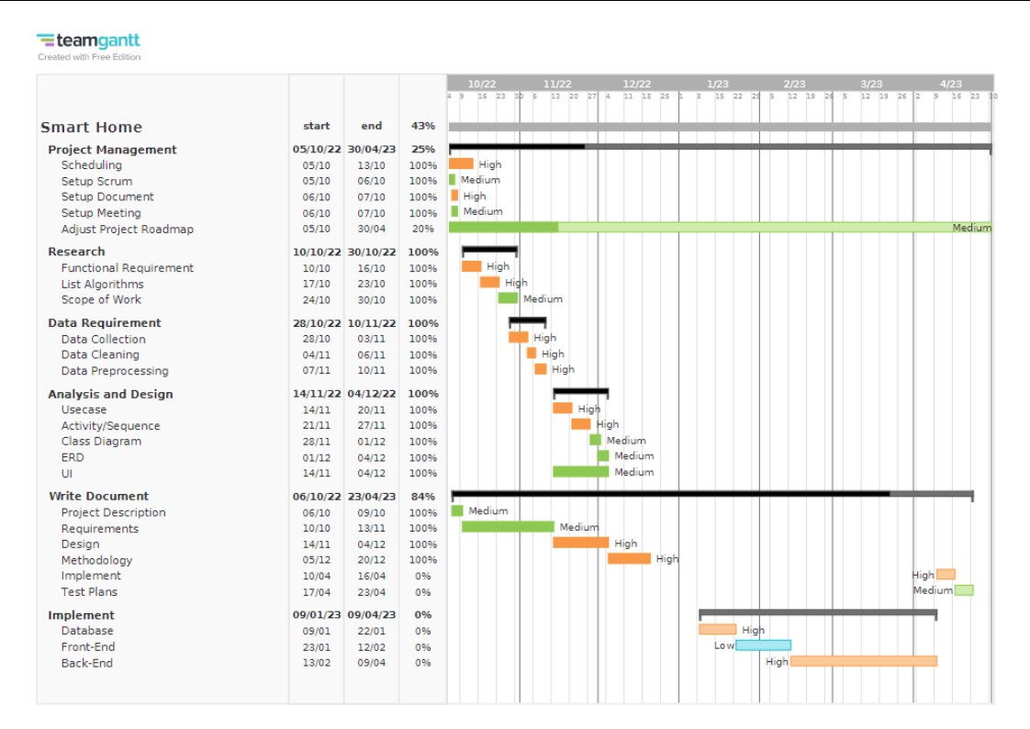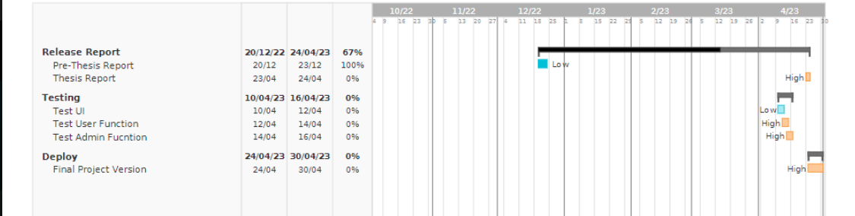

Figure 2. Gantt Chart

#### **1.6.2. Work Breakdown Structure**

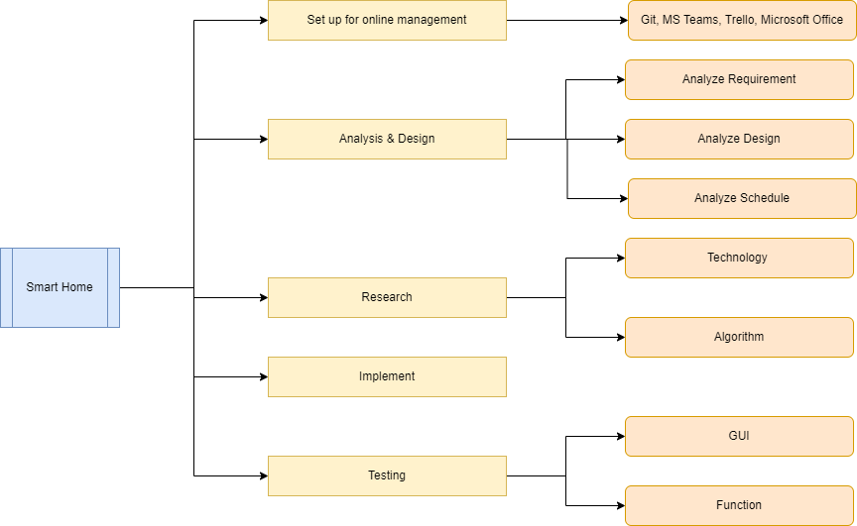

Figure 3. Work Breakout Structure

#### **1.6.3. Schedule and milestone**

|  |  |  |  |  |  |  |  |
| --- | --- | --- | --- | --- | --- | --- | --- |
| **Prethesis/Thesis** | **Task/ SubTask** | **Type** | **Priority** | **Status** | **Start** | **End** | **Estimate (days)** |
| Pre-thesis & Thesis | **Project Management** | **Task** | **Medium** | **DOING** | **05/10/2022** | **30/04/2023** | **207** |
| Pre-thesis | Scheduling | Subtask | High | DONE | **05/10/2022** | **13/10/2022** | **8** |
| Pre-thesis | Setup Scrum | Subtask | Medium | DONE | **05/10/2022** | **06/10/2022** | **1** |
| Pre-thesis | Setup Document | Subtask | High | DONE | **06/10/2022** | **07/10/2022** | **1** |
| Pre-thesis | Setup Meeting | Subtask | Medium | DONE | **06/10/2022** | **07/10/2022** | **1** |
| Pre-thesis & Thesis | Adjust project roadmap | Subtask | Medium | DOING | **05/10/2022** | **30/04/2023** | **207** |
| Pre-thesis | **Research** | **Task** | **High** | **DONE** | **10/10/2022** | **30/10/2022** | **20** |
| Pre-thesis | Functional Requirement | Subtask | High | DONE | **10/10/2022** | **16/10/2022** | **6** |
| Pre-thesis | List Algorithms | Subtask | High | DONE | **17/10/2022** | **23/10/2022** | **6** |
| Pre-thesis | Scope of Work | Subtask | Medium | DONE | **24/10/2022** | **30/10/2022** | **6** |
| Pre-thesis | **Data Requirement** | Task | High | **DONE** | **31/10/2022** | **13/11/2022** | **13** |
| Pre-thesis | Data Collection | Subtask | High | DONE | **31/10/2022** | **06/11/2022** | **6** |
| Pre-thesis | Data Cleaning | Subtask | High | DONE | **07/11/2022** | **09/11/2022** | **2** |
| Pre-thesis | Data Preprocessing | Subtask | High | DONE | **10/11/2022** | **13/11/2022** | **3** |
| Pre-thesis | **Analysis and Design** | **Task** | **High** | **DONE** | **14/11/2022** | **04/12/2022** | **20** |
| Pre-thesis | Usecase | Subtask | High | DONE | **14/11/2022** | **20/11/2022** | **6** |
| Pre-thesis | Activity/Sequence | Subtask | High | DONE | **21/11/2022** | **27/11/2022** | **6** |
| Pre-thesis | Class Diagram | Subtask | Medium | DONE | **28/11/2022** | **01/12/2022** | **3** |
| Pre-thesis | ERD | Subtask | Medium | DONE | **01/12/2022** | **04/12/2022** | **3** |
| Pre-thesis | UI | Subtask | Medium | DONE | **14/11/2022** | **04/12/2022** | **20** |
| Pre-thesis/Thesis | **Write Document** | **Task** | **Medium** | **DONE** | **06/10/2022** | **20/04/2023** | **196** |
| Pre-thesis | Project Description | Subtask | Medium | DONE | **06/10/2022** | **09/10/2022** | **3** |
| Pre-thesis | Requirements | Subtask | Medium | DONE | **10/10/2022** | **13/11/2022** | **34** |
| Pre-thesis | Design | Subtask | High | DONE | **14/11/2022** | **04/12/2022** | **20** |
| Pre-thesis | Methodology | Subtask | High | DONE | **05/12/2022** | **20/12/2022** | **15** |
| Thesis | Implement | Subtask | High | TO DO | **10/04/2023** | **16/04/2023** | **6** |
| Thesis | Test Plans | Subtask | Medium | TO DO | **17/04/2023** | **23/04/2023** | 6 |
| Thesis | **Implement** | **Task** | **High** | **TO DO** | **09/01/2023** | **09/04/2023** | **90** |
| Pre-thesis & Thesis | Database | Subtask | High | TO DO | **09/01/2023** | **22/01/2023** | 13 |
| Thesis | Front-End | Subtask | Low | TO DO | **23/01/2023** | **12/02/2023** | 20 |
| Thesis | Back-End | Subtask | High | TO DO | **13/02/2023** | **09/04/2023** | 55 |
| Pre-thesis/Thesis | **Release Report** | **Task** | **Medium** | **TO DO** | **20/12/2022** | **24/04/2023** | **125** |
| Pre-thesis | Pre-Thesis Report | Subtask | Low | DONE | **20/12/2022** | **23/12/2022** | **3** |
| Thesis | Thesis Report | Subtask | High | TO DO | **23/04/2023** | **24/04/2023** | 1 |
| Thesis | **Testing** | **Task** | **High** | **TO DO** | **10/04/2023** | **16/04/2023** | **6** |
| Thesis | Test UI | Subtask | Low | TO DO | **10/04/2023** | **12/04/2023** | 2 |
| Thesis | Test User Function | Subtask | High | TO DO | **12/04/2023** | **14/04/2023** | 2 |
| Thesis | Test Admin Fucntion | Subtask | High | TO DO | **14/04/2023** | **16/04/2023** | 2 |
| Thesis | **Deploy** | **Task** | **Low** | **TO DO** | **24/04/2023** | **30/04/2023** | **6** |
| Thesis | Final Project Version | Subtask | High | TO DO | 24/04/2023 | 30/04/2023 | 6 |

Table 6. Product Backlog

#### **1.6.4. Process Development**

Flexible planning techniques for team participation and interaction are required to complete the project methodically. Scrum is one of the most well-liked adaptable frameworks. The project manager will first invest time in gathering information about the project specifications and organizing the sprint and general product backlogs. The project manager will call a meeting to go over and allocate duties after the preliminary plan has been made. Throughout the project, a daily and weekly scrum meeting will be held to assist keep the project on track by carrying out frequent checks and assessments. One sprint will be used to deploy and test the tasks until the project manager is happy with the result, at which point the next print can be started.

### **1.7. Risk Management**

|  |  |  |  |  |  |
| --- | --- | --- | --- | --- | --- |
| **#** | **Risk Title** | **Risk Description** | **Affect** | **Impact** | **Risk Response Plan** |
| 1 | Communication | Because much of the work for this project will be done at home after school, contacting project participants may be difficult, and other network connection issues may interfere. | Delaying project completion and producing poor software | High | Using only one online meeting software with a fixed meeting schedule. |
| 2 | Misunderstood | Lack of communication, resulting in uncertainty and ambiguity | Producing things that do not meet the specifications owing to missing information. This will result in wasting time and money redoing the task. | Low | To ensure that all team members understand, project managers must ask and engage with them on a frequent basis. |
| 3 | Changeable | Team members change the files, data, or code without notify. | When an issue arises, the team must spend time reviewing each assignment again. | Medium | Using Trello to record every work completed or in progress, as well as asking members about their tasks progess |
| 4 | Wrong data | Dev insert wrong data | Causing error to the customer | High | The developer must build a proper system so that the system can run more smoothly. |
| 5 | Timeline | During the project, have many homework, test, exam | Lack of time to complete projects results in worse product quality. | Medium | Each participant is required to announce their schedule. If they encounter any difficulties, they must notify the other members. |

Table 7. Risk Requirement

### **1.8. Conclusion**

The idea of creating a smart home system in which household equipment connected to a home network can be controlled by voice. This project will involve the development of a voice-controlled household appliance system. This project is the result of all project participants' perseverance, as well as the course instructor's assistance. This project has given us a fantastic opportunity to learn and experiment. Furthermore, we were able to actively investigate and learn about the processes involved in designing and implementing smart home solutions.

## **Chapter 2: Requirements**

### **2.1. Product Use Cases.**

#### **2.1.1. Use Case Diagram**

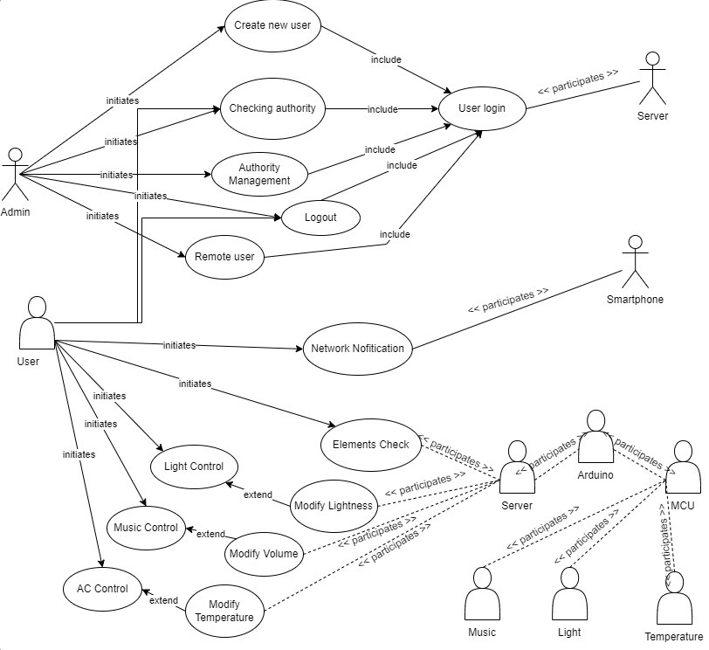

Figure 4. Use Case Diagram

#### **2.1.2. Product Use Case List**

|  |  |
| --- | --- |
| Use Case 1: Light Control | |
| Actor | User |
| Action Goal | Turn on or off the light |
| Pre-condition | User must be authenticated |
| Success End Condition | The light is turn on or off by the users’s |
| Failed End Condition | Server cannot do user’s command |
| Basic Flow | 1. Cellphone shows the application's main menu.  2. User selects the light function.  3. Cellphone shows the light function interface.  4. The user communicates with the server via voice message.  5. The message is processed by the server, and a signal is sent to the Arduino.  6. The Arduino receives the signal from the server, transfers it to the MCU, and then runs status check.  7. The MCU receives the Arduino signal and turns on or off the switch. |

Table 8. Use Case 1

|  |  |
| --- | --- |
| Use Case 2: Modify Brightness | |
| Actor | User |
| Action Goal | Modify the brightness of the light |
| Participating Actor | Arduino, Light |
| Pre-condition | User must be authenticated |
| Success End Condition | The brightness of light is controlled by the users |
| Failed End Condition | Server cannot do user’s command |
| Basic Flow | 1. Cellphone shows the application's main menu.  2. User selects the light function.  3. Cellphone shows the light function interface.  4. The user communicates with the server via voice message.  5. The message is processed by the server, and a signal is sent to the Arduino.  6. The Arduino receives the signal from the server, transfers it to the MCU, and then runs status check.  7. The MCU receives the Arduino signal and modify the brightness. |

Table 9. Use Case 2

|  |  |
| --- | --- |
| Use Case 3: Music Control | |
| Actor | User |
| Action Goal | Turn on or off the music player |
| Participating Actor | Arduino, Music Player |
| Pre-condition | User must be authenticated |
| Success End Condition | The music is turn on or off by the users’s |
| Failed End Condition | Server cannot do user’s command |
| Basic Flow | 1. Cellphone shows the application's main menu.  2. User selects the music function.  3. Cellphone shows the music function interface.  4. The user communicates with the server via voice message.  5. The message is processed by the server, and a signal is sent to the Arduino.  6. The Arduino receives the signal from the server, transfers it to the MCU, and then runs status check.  7. The MCU receives the Arduino signal and turns on or off the switch. |

Table 10. . Use Case 3

|  |  |
| --- | --- |
| Use Case 4: Modify Volume of Music | |
| Actor | User |
| Action Goal | Increase or decrease the volume of the music player |
| Participating Actor | Arduino, Music Player |
| Pre-condition | User must be authenticated |
| Success End Condition | The music volume is modified by the users’s instruction |
| Failed End Condition | Server cannot do user’s command |
| Basic Flow | 1. Cellphone shows the application's main menu.  2. User selects the music function.  3. Cellphone shows the music function interface.  4. The user communicates with the server via voice message.  5. The message is processed by the server, and a signal is sent to the Arduino.  6. The Arduino receives the signal from the server, transfers it to the MCU, and then runs status check.  7. The MCU receives the Arduino signal and modify the volume of music. |

Table 11. Use Case 4

|  |  |
| --- | --- |
| Use Case 5: Element Status Check | |
| Actor | User |
| Action Goal | Check the current status of element in the system |
| Participating Actor | Arduino |
| Pre-condition | User must be authenticated  Server and elements must connected. |
| Success End Condition | The cellphones interface display the status of element |
| Failed End Condition | The status information reflects server and smart element failure. |
| Basic Flow | 1. The main menu of the software is displayed on the phone.  2. The user selects the status check function.  3. The elements send a status message to the MCU, and the MCU sends the data to the Arduino  4. Arduino sends a message to the server, and the server sends a message to the cellphone.  after processing  5. Cellphone receives the signal and displays status information on the UI. |

Table 12. Use Case 5

|  |  |
| --- | --- |
| Use Case 6: Login | |
| Actor | User |
| Action Goal | Check the current status of element in the system |
| Participating Actor | Server |
| Pre-condition | User account created in the server. |
| Success End Condition | User account created in the server. |
| Failed End Condition | User input wrong username or password. |
| Basic Flow | 1. The cellphone displays the login screen.  2. The user enters the username and password.  3. The smartphone submits the username and password to the server.  4. The server validates the user's login and password in the database and sends feedback information to the cellphone.  5. The cellphone displays the main menu to the user. |

Table 13. Use Case 6

|  |  |
| --- | --- |
| Use Case 7: Login(Admin) | |
| Actor | Admin |
| Action Goal | Check the current status of element in the system |
| Participating Actor | Server |
| Pre-condition | Admin account created in the server. |
| Success End Condition | Admin account created in the server. |
| Failed End Condition | Admin input wrong username or password. |
| Basic Flow | 1. The cellphone displays the login screen.  2. The admin enters the username and password.  3. The smartphone submits the username and password to the server.  4. The server validates the admin's login and password in the database and sends feedback information to the cellphone.  5. The cellphone displays the control menu to the admin. |

Table 14. Use Case 7

|  |  |
| --- | --- |
| Use Case 8: Create New Account | |
| Actor | User |
| Action Goal | Create new account for new user and save to server |
| Participating Actor | Server |
| Pre-condition | The username of the new account has not been taken |
| Success End Condition | User account created and stored information in the server. |
| Failed End Condition | The username or passwork has already taken. |
| Basic Flow | 1. The phone displays the UI for creating a new account.  2. The user enters personal information.  3. The cellphone determines whether the login and password follow the rules.  4. The cellphone transmits the information to the server, which stores the information about the new accounts.  5. The server gives feedback information to the smartphone, which displays the login interface to the user. |

Table 15. Use Case 8

|  |  |
| --- | --- |
| Use Case 9: Remove User | |
| Actor | Admin |
| Action Goal | Successful delete a user |
| Participating Actor | Server |
| Pre-condition | The information of chosen user must be saved on the server  The login-user must be admin. |
| Success End Condition | Admin delete all information about that user in the server. |
| Failed End Condition | The information of that user can not found |
| Basic Flow | Include UC7  1. The phone displays the UI for creating a new account.  2. The user enters personal information.  3. The cellphone determines whether the login and password follow the rules.  4. The cellphone transmits the information to the server, which stores the information about the new accounts.  5. The server gives feedback information to the smartphone, which displays the login interface to the user. |

Table 16. Use Case 9

|  |  |
| --- | --- |
| Use Case 10: Logout | |
| Actor | User |
| Action Goal | Logout and protect information from the server |
| Participating Actor | Server |
| Pre-condition | User must log in before |
| Success End Condition | User logout from the system and no instruction can be done. |
| Failed End Condition | none |
| Basic Flow | Include UC6  1. The phone displays the application's main menu.  2. The user selects the log out button.  3. The phone clears the current user's information and displays the login interface. |

Table 17. Use Case 10

|  |  |
| --- | --- |
| Use Case 11: Logout (Admin) | |
| Actor | Admin |
| Action Goal | Logout and protect information from the server |
| Participating Actor | Server |
| Pre-condition | User must log in before |
| Success End Condition | User logout from the system and no instruction can be done. |
| Failed End Condition | none |
| Basic Flow | Include UC7  1. The phone displays the application's main menu.  2. The admin selects the log out button.  3. The phone clears the current user's information and displays the login interface. |

Table 18. Use Case 11

|  |  |
| --- | --- |
| Use Case 12: Authority Management | |
| Actor | Admin |
| Action Goal | Manage permission of all users |
| Participating Actor | Server |
| Pre-condition | The login user must be admin  At least 1 login user in database |
| Success End Condition | Following management, user authorities were adjusted |
| Failed End Condition | The authority of that user not changed. |
| Basic Flow | After UC7  1. Cellphone displays the administrator's management interface.  2. Administrator selects the users who need to be adjusted.  3. Cellphone displays the present authorities of this user.  4. The administrator changes this user's permissions.  5. The smartphone communicates the changed information to the server, and the server adjusts the information in the database.  6. The server sends feedback information to the cellphone, and the interface displays the user's current authorities. |

Table 19. Use Case 12

|  |  |
| --- | --- |
| Use Case 13: Check Authority | |
| Actor | User |
| Action Goal | Check the authority of current user |
| Participating Actor | Server |
| Pre-condition | The login user must be authenticated  Server and Cellphone connected to same network |
| Success End Condition | User authority display on the screen |
| Failed End Condition | The connection between Server and Cellphone has error. |
| Basic Flow | After UC6  1.The user selects the function of authority.  2. The cellphone sends the check instruction to the server.  3. The server verifies the database and returns the authority information to the cellphone.  4. The smartphone shows the authority on the interface. |

Table 20. Use Case 13

|  |  |
| --- | --- |
| Use Case 14: Network Error Notification | |
| Actor | User |
| Action Goal | Send the notification about network error to users. |
| Participating Actor | Cellphone |
| Pre-condition | Cellphone and Server disconnected |
| Success End Condition | Notification display on the screen |
| Failed End Condition | The network not has error |
| Basic Flow | After UC6  1. The cellphone analyzes the current network status.  2. If the network status is unusual, an error notification appears on the screen |

Table 21. Use Case 14

### **2.2. Functional Requirements**

|  |  |  |  |
| --- | --- | --- | --- |
| **Req.ID** | **Requirement Name** | **Detailed Decription** | **Priority** |
| **001** | Register Account | When the users/admin initially login to the system, they will be asked to register for their account | Low priority |
| **002** | Login | If the users/admin have already have an account, they can login | Low priority |
| **003** | Change Password | This function allows the users/admin to change their password | Low priority |
| **004** | Logout | The users/admin can logout after they finish their process | Low priority |
| **005** | Manage Users | Allow the admin to see the user’s information | Low priority |
| **006** | Light control | The users can modify the lightness | High priority |
| **007** | Music control | The users can modify the Volume | High priority |
| **008** | AC control | The users can modify the temperature | High priority |
| **009** | Element check | The users can check te server | High priority |
| **010** | Identity Verification | Ask for the users to verify their identity by enter the OTP code ( if it’s wrong more than 3 times, the account will be clocked) | Low priority |
| **011** | Checking authority | The system will check the account which is User or Admin | High prority |
| **012** | Network Notification | The system will check the internet connection and announce to user SMS | Medium Prority |

Table 22. Functional Requirements

### **2.3. Data Requirements**

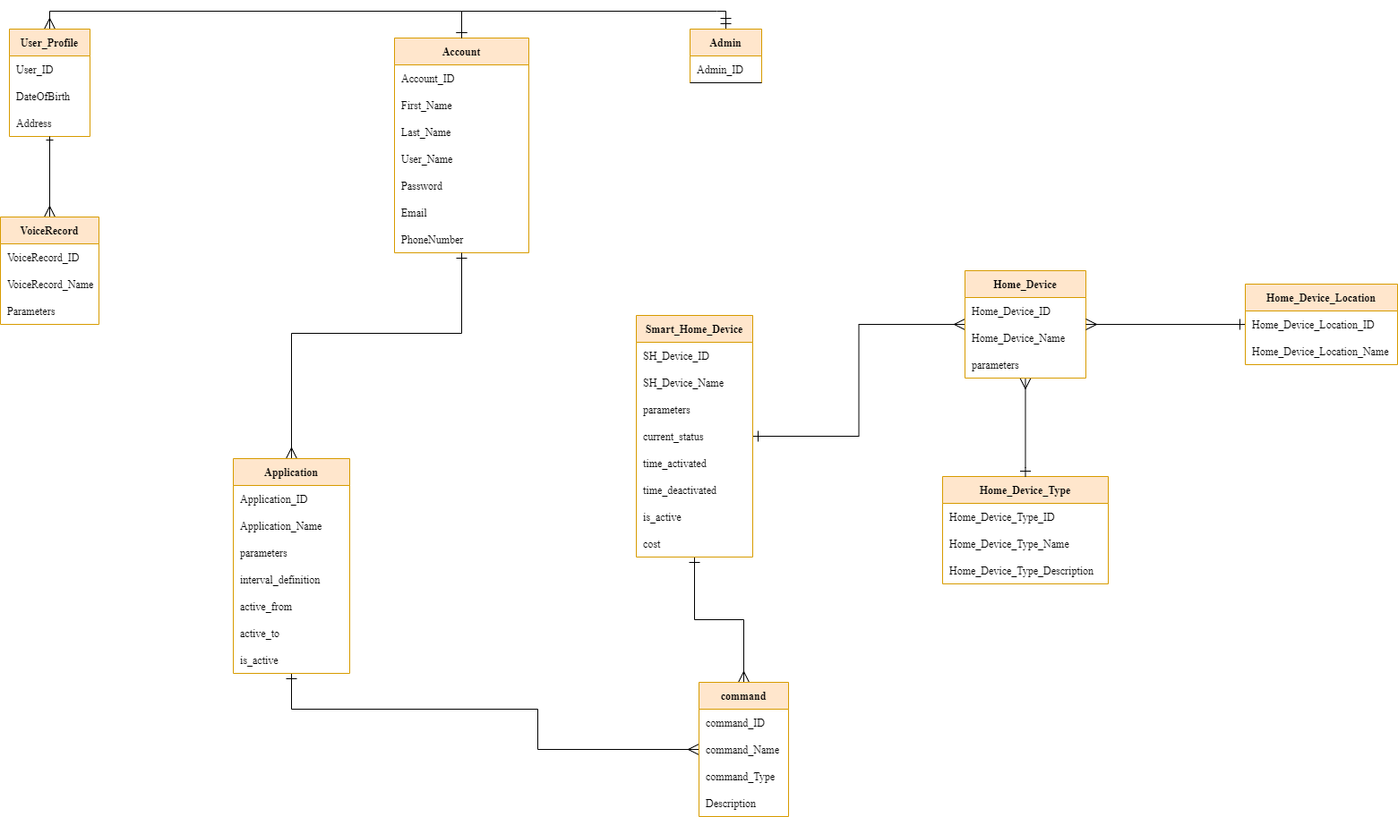

Figure 5. UML Class Diagram

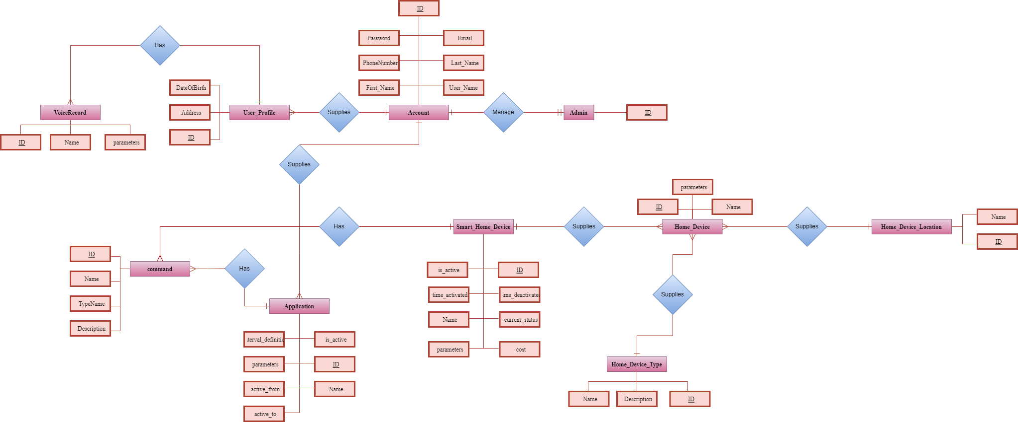

Figure 6. ERD Diagram

The data is created with many specifications in order to satisfy the user's needs while maintaining the privacy of the user's data and information. There can be only one admin account used to manage data for all customer accounts. Following assistance with the installation of one technology in the customer's home, it is possible to manage a large number of devices in various ways depending on the type and location of each device. Additionally, each customer's account will be able to install the app for managing smart home devices via their smartphone after paying for the service. Of course, multiple applications can be installed under a single account to control a single smart home device at home. For smart home technology, there can be a wide variety of commands inside the program, and they can all be issued simultaneously.

### **2.4. Performance Requirements**

The amount of time delays that a smart home experiences are measured as latency. Inherently, Wi-Fi and other wired IP networks add latency as well as a number of external factors (lower speeds, packet loss, congestion, etc.). It may take several seconds for moisture from a shower to reach a humidity sensor in a bathroom, be measured, and then be reported. Delay is also influenced by the location of a sensor. Wi-Fi and other wired IP networks by their very nature include latency as well as a number of external factors (congestion, packet loss, interference, lower speeds, etc.). Analysis and Processing.

### **2.5. System Requirements**

**What are the voice recognition system?**  
Voice recognition technology is a software program or hardware device that has the ability to decode the human voice. Sometimes referred to as voice-activated or speech recognition software, this technology has become more and more popular in recent years among everyday consumers.

**Which algorithm is best for voice recognition?**  
Modern voice recognition algorithms use deep learning to build an all-encompassing model. The artificial neural network, a multi-layered design loosely based on our brains, is the primary algorithm. These methods, also known as Recurrent Neural Networks (RNN), are excellent for sequential data, such as voice. Since sentences usually contain words, understanding the previous information and recycling it can greatly improve speech recognition. A probabilistic method is used by Connectionist Temporal Classification (CTC) to match the labels (transcripts) with the training data (audio).

### **2.6. Security Requirements**

In the design and development of technology and application services, the security component is crucial. Securing vendor-user communications can be done using a number of popular security tactics. We will opt for notification-level security for this project. Email/message public key approaches are used to authenticate the protocol with a symmetric key before encrypting packets over the network. Users can therefore examine and ensure the confidentiality of their personal account information thanks to this strict security. However, these messages are susceptible to assaults based on rapid message change, which can have a variety of negative effects like illegal access, information disclosure, or identity theft. In order to ensure end-to-end security and enable the protection of specific bits of information, web services, and message-level security covered by several standards, including WS-Security, provide techniques for specific users.

**User security choices include:**

* Recommends users change their passwords and update their voice every year
* Allows the admin system page to verify and search for customer information that is utilizing the service for customer care
* Allow users to update account details by texting or emailing the OTP confirmation code.
* Allow users to check user voices that have been recorded into the system.

### **2.7. Usability Requirements**

Certain usability concerns persist with voice-controlled technology. Despite the fact that voice recognition algorithms struggle with accented voices, a user's request should be accepted and fulfilled. If the system is unable to properly identify or interpret the user's command, it should display some related options based on the command.

Furthermore, just because a system is voice-controlled does not mean it can only be operated via voice commands. Users should be able to use the system by pressing buttons or manually configuring it.

## **Chapter 3: Design**

### **3.1. System Architecture**

#### **3.1.1. System Architech:**

Through a smart phone, administrators and users can access the smart home management system and manage everything. Remote Client is connected via Ethernet, and the Remote Client's primary function is to control the lighting, audio, and air conditioning that are managed by the user or administrator via phone.

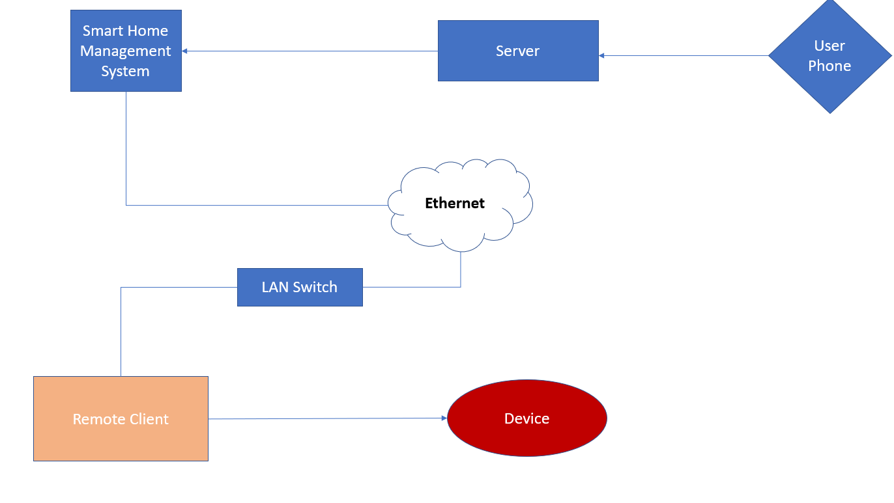

Figure 7. System Architecture

#### **3.1.2. MVC:**

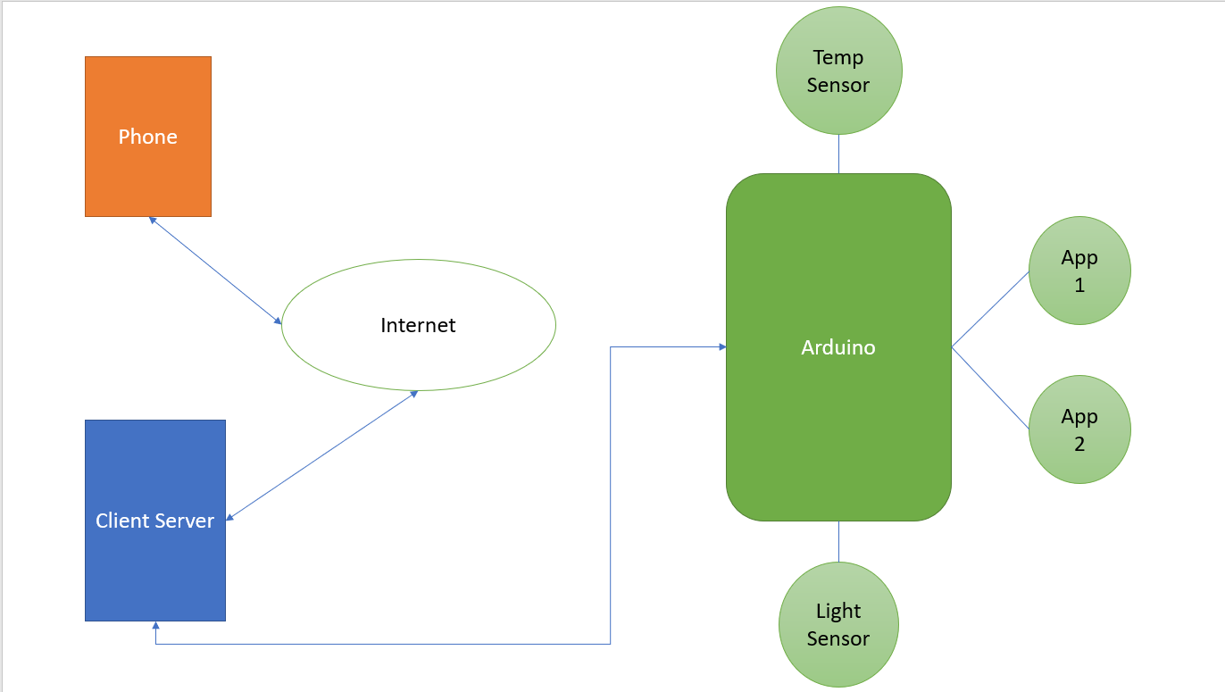

Figure 8. MVC Diagram

Smart Phone ( View ) and Server ( Controller ) connected via Internet. The Arduino ( Model ) connected with Server based on USB cable. Through the phone, the user makes a request to the server. When the Model responds to the server's commands after receiving the request, the server notifies the user via phone of whether the request has been granted or denied.

### **3.2. Database Structure**

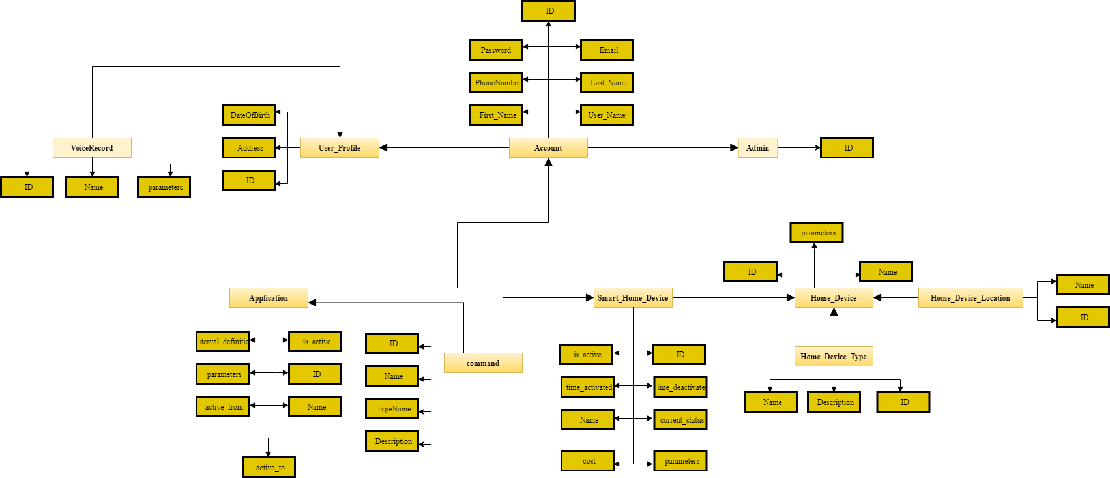

Figure 9. Database Structure

Account information includes First Name, Last Name, Email, Password, Username, and Phone number for each profile. The Account is divided into the User and Admin roles using this Role field. A Smart Home Device has one or many Home Devices (ID, time activate, time deactivate, name, current status, parameters, cost, is active), and an Account has one or many Applications (ID, Name, is active, interval definition, parameters, active from, active to). A user can record many voice messages and issue many commands to one smart home device.

### **3.3. Class Diagram**

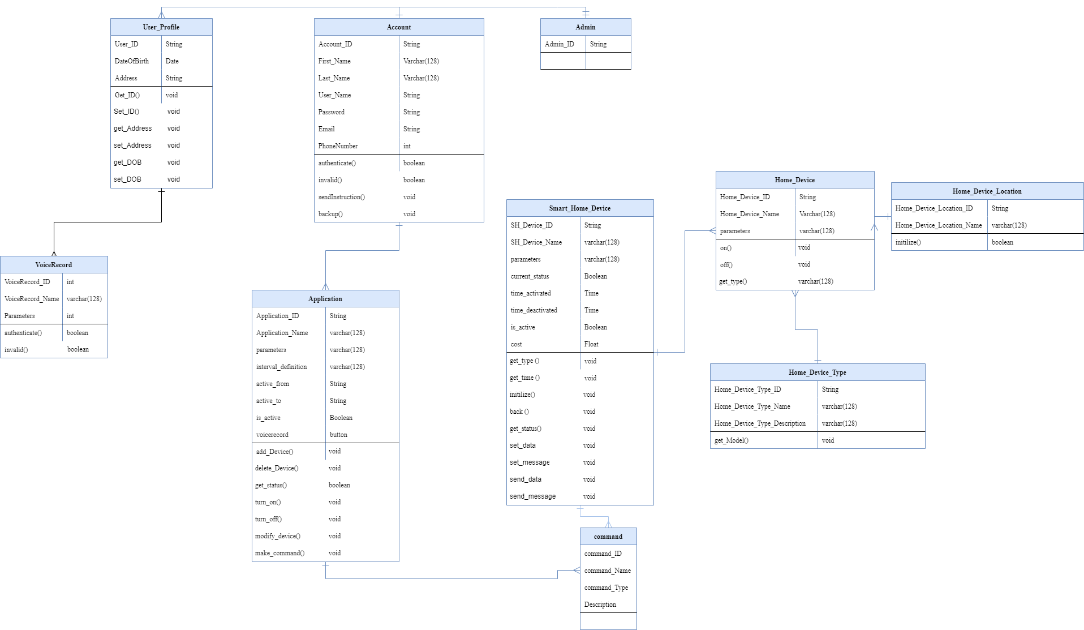

Figure 10. Class Diagram

### **3.4. Database Design Diagram**

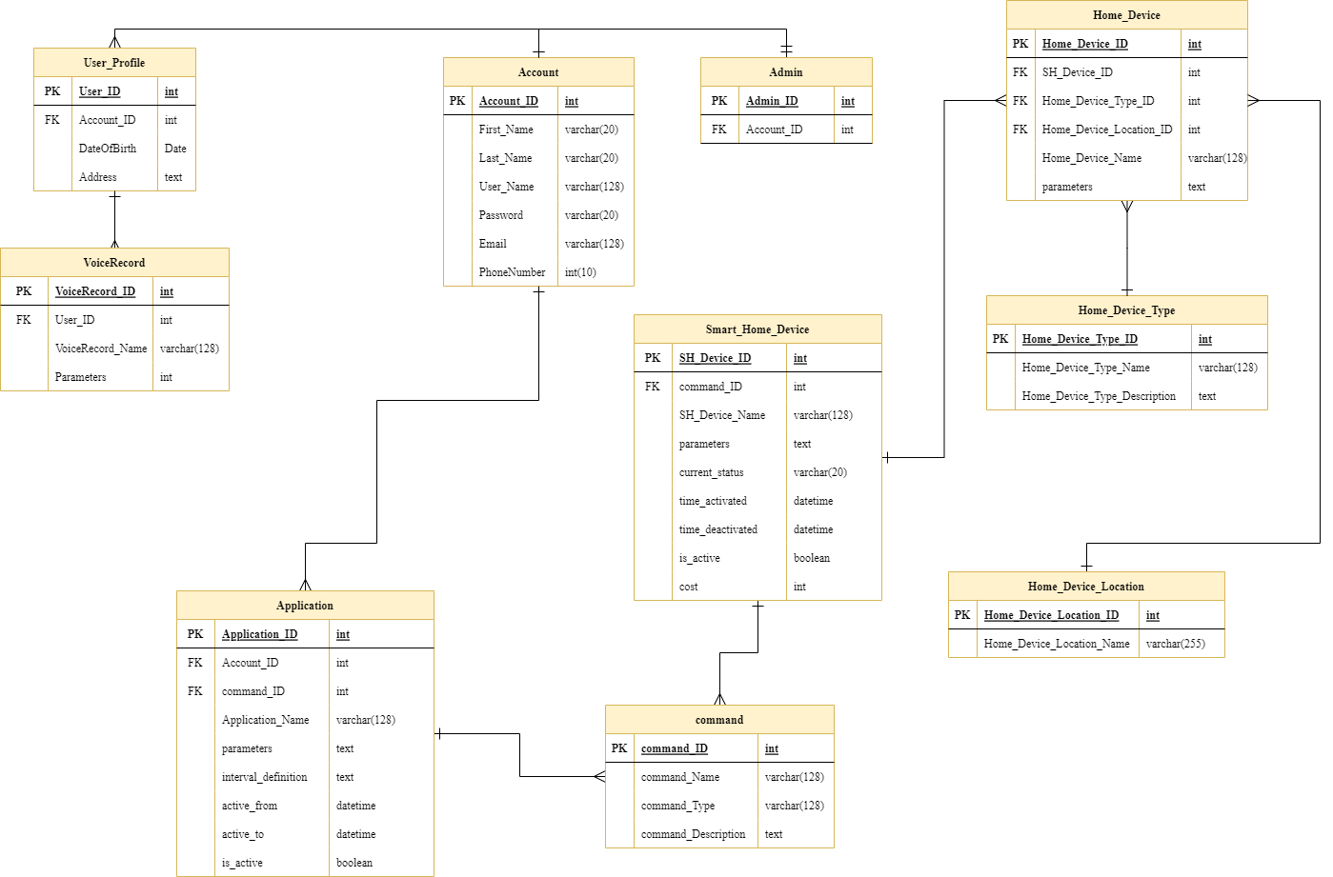

Figure 11. Database Design Diagram

### **3.5. Sequence Diagram**

Figure 12. Sequence Diagram

## **CHAPTER 4: METHODOLOGY**

### **4.1. Overview**

By definition, a smart home has a lot of smart devices connected to the HAN (Home Area Network) that collect and/or share data about specific traits. A high-level system design must adopt a comprehensive, user-centered perspective and focus on meeting the demands of the user in order to support the development of intelligence-based information management tools. It is a knowledge-based approach; similar approaches have been used in system design before, such as to manage human interactions in extended workplaces or to evaluate virtual reality tools for particular applications, but this approach is unique to the design of smart homes. Our current efforts are directed toward clearing the backlog in sound recognition and improving the algorithm.

### **4.2. Technology**

#### **4.2.1. Voice Intellligence**

Voice intelligence is the use of artificial intelligence, machine learning, and speech recognition to examine calls, voicemails, and digital conversations. Because some voice intelligence platforms incorporate machine learning, the system is essentially self-improving. Your voice intelligence system learns more and improves its processing abilities as more data from the calls made by your company is collected.

#### **4.2.2****. IoT**

### The Internet of Things (IoT) ecosystem is made up of web-enabled smart devices that employ embedded systems, such as processors, sensors, and communication gear, to gather, communicate, and act on the data they get from their surroundings. By connecting to an IoT gateway or other edge device, which either sends data to the cloud for analysis or analyzes it locally, IoT devices exchange the sensor data they gather. These gadgets converse with other similar devices on occasion, acting on the data they exchange. Although individuals may engage with the devices to set them up, give them instructions, or retrieve the data, the gadgets accomplish the majority of the job without their help.

### **4.3. Algorithm**

The spoken commands are recorded using a MAX9814 microphone amplifier, and the speech recognition algorithm is run on an Arduino Nano. However, the method's software application is where its genius lies. It involves some interaction between the Arduino Nano and specialized PC software that we will create. We had to first enhance the Nano's ADC in order to acquire sufficient sample rates for speech processing before we could record example audio instructions, or utterances. In order to process audio, we need to have a sample rate of 9 ksps, which requires some low-level programming.

To start analyzing the utterances, divide each sample speech into segments of 50 milliseconds. Think about breaking a single word into its constituent syllables. separating the "se-" from the "-ven," as in "seven." Each segment of each utterance was evaluated for the energy of 5 distinct frequency bands because 50 ms is either too long or too short to capture each word clearly. Normally, a Fourier transform is used to accomplish this, but since the Nano lacks the processing power necessary to carry out a real-time Fourier transform, we turned to an alternative technique. To more accurately measure the signal's energy in each frequency band, we substituted 5 sets of digital bandpass filters.

A PC program creates "templates" based on the sample utterances we will produce using the frequency spectrum for each segment. This technique is based on the measurement of the energy of each frequency band with respect to the segment template. An a.h file produced by the PC program can be immediately compiled on the Nano. We give the example of being able to recognize the numbers 0 through 9, but the commands could also be changed to "start" or "stop," for instance.

**Key Words**

· The spoken commands are recorded using a MAX9814 microphone amplifier, and the speech recognition algorithm is run on an Arduino Nano.

· We had to first enhance the Nano's ADC in order to acquire sufficient sample rates for speech processing before we could record example audio instructions, or utterances.

· A PC program creates "templates" based on the sample utterances we will produce using the frequency spectrum for each segment.

· This technique is based on the measurement of the energy of each frequency band with respect to the segment template.

· We give the example of being able to recognize the numbers 0 through 9, but the commands could also be changed to "start" or "stop," for instance.

### **4.4. User Interface Design**

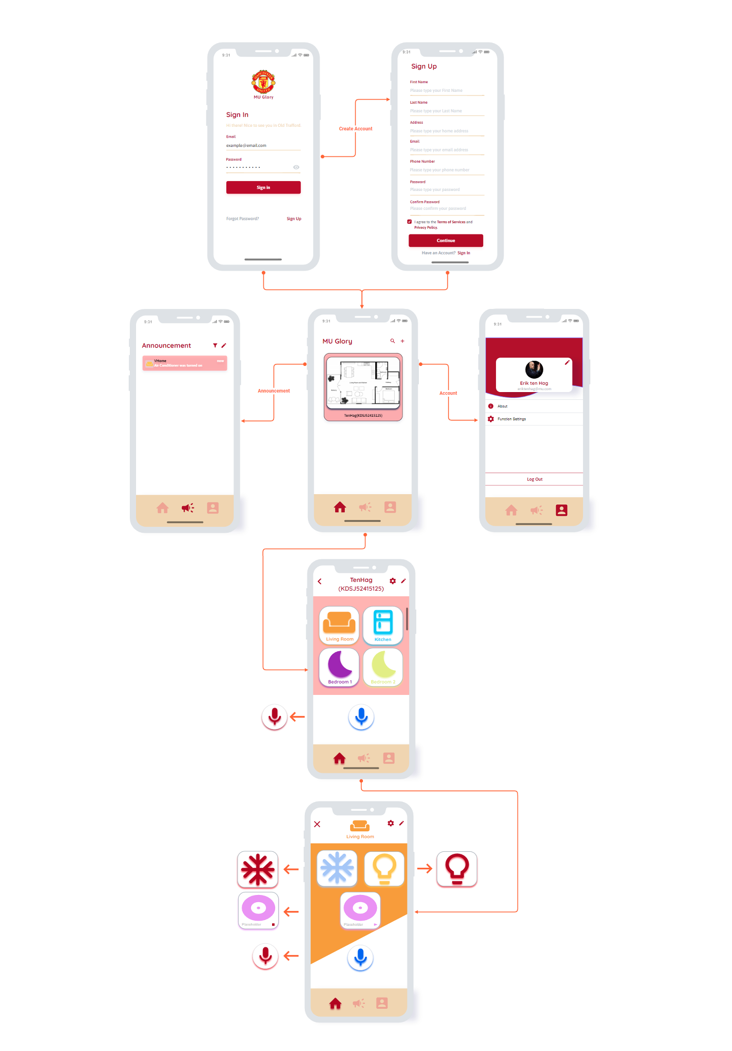

Figure 13. UI/UX Design

## **REFERENCES**

1. Hoilett, Orlando. “Speech Recognition on an Arduino Nano?” *Speech Recognition on an Arduino Nano? | Hackaday*, 26 May 2021, hackaday.com/2021/05/26/speech-recognition-on-an-arduino-nano.

2. Choudhary, Ashish. “Speech Recognition Using Arduino.” *Arduino Speech Recognition*, 16 July 2020, circuitdigest.com/microcontroller-projects/arduino-speech-recognition?fbclid=IwAR0QJDzl0PIFolbrLWauvA37wYsNUybnn0c6SmUPLzk6PRFZZ1qfVEp9vHA.

3. “Smart Home: What Is Voice Controlled Home Automation?” *Smart Home Works*, 9 June 2020, smarthomeworks.com.au/2020/06/09/what-is-voice-controlled-home-automation.

4. michaelmckey. “Arduino Nano Voice Recorder With the MAX9814 Microphone.” *Instructables*, www.instructables.com/Arduino-Nano-Voice-Recorder-With-the-MAX9814-Micro. Accessed 22 Dec. 2022.

5. Bin Sulaiman, Rejwan. (2018). VOICE CONTROLLED HOME AUTOMATION. 10.13140/RG.2.2.32540.23683.

6. “What Is Voice Intelligence?” *BigCommerce*, [www.bigcommerce.com/ecommerce-answers/what-is-voice-intelligence. Accessed 23 Dec. 2022](http://www.bigcommerce.com/ecommerce-answers/what-is-voice-intelligence.%20Accessed%2023%20Dec.%202022).

7. “Home Smart IoT Home: Domesticating IoT.” *Toptal Design Blog*, www.toptal.com/designers/interactive/smart-home-domestic-internet-of-things. Accessed 23 Dec. 2022.

8. “Secure Remote Anonymous User Authentication Scheme for Smart Home Environment.” *Secure Remote Anonymous User Authentication Scheme for Smart Home Environment - ScienceDirect*, 9 Jan. 2020, [www.sciencedirect.com/science/article/abs/pii/S2542660520300019](http://www.sciencedirect.com/science/article/abs/pii/S2542660520300019).

9. Association, Home Technology. “Voice Control in the Smart / Connected Home, What You Need to Know.” *Voice Control in the Smart / Connected Home, What You Need to Know*, htacertified.org/app/articles/voice-control-in-the-smart-home. Accessed 23 Dec. 2022.

10. Hirt, Meredith. “10 Smart Home Trends This Year.” *Forbes Home*, 26 Sept. 2022, [www.forbes.com/home-improvement/internet/smart-home-tech-trends](http://www.forbes.com/home-improvement/internet/smart-home-tech-trends).

11. “A Thorough Guide to Home Automation and Smart Home Technology.” *GoNetspeed*, www.otelco.com/resources/smart-home-guide. Accessed 23 Dec. 2022.

12. Rajabzadeh, Amir, et al. “[PDF] a Mobile Application for Smart House Remote Control System | Semantic Scholar.” *[PDF] a Mobile Application for Smart House Remote Control System | Semantic Scholar*, 1 Jan. 2015, [www.semanticscholar.org/paper/A-Mobile-Application-for-Smart-House-Remote-Control-Rajabzadeh-Manashty/d3b493a52e4fda9d40f190ddf9541dbf51ed7658](http://www.semanticscholar.org/paper/A-Mobile-Application-for-Smart-House-Remote-Control-Rajabzadeh-Manashty/d3b493a52e4fda9d40f190ddf9541dbf51ed7658).

13. “What Is IoT (Internet of Things) and How Does It Work? - Definition From TechTarget.com.” *IoT Agenda*, 1 Mar. 2022, [www.techtarget.com/iotagenda/definition/Internet-of-Things-IoT](http://www.techtarget.com/iotagenda/definition/Internet-of-Things-IoT).

14. @Vertabelo. “The Smart Home Data Model.” *Vertabelo Data Modeler*, 24 Jan. 2019, vertabelo.com/blog/the-smart-home-data-model.

15. “Trello.” *Trello*, trello.com/w/prethesiscn/home. Accessed 23 Dec. 2022.

16. “Diagram.drawio.” *Google Docs*, drive.google.com/file/d/1xT9-tfSsMh1TYTH8JKc2eby46VbhzdCq/view?usp=embed_facebook. Accessed 23 Dec. 2022.

17. “Sign up and Log In - Moqups App.” *Sign up & Log In - Moqups App*, app.moqups.com/wrnhTEnk8WWPIum847QeSTkdxDRPUEty/edit/page/a880590a1. Accessed 23 Dec. 2022.

18. “Requirements Document Example.” *Requirements Document Example*, web.cse.ohio-state.edu/~bair.41/616/Project/Example_Document/Req_Doc_Example.html#Func. Accessed 23 Dec. 2022.

19. “UML Class Diagram Tutorial.” *Lucidchart*, www.lucidchart.com/pages/uml-class-diagram. Accessed 23 Dec. 2022.

20. “Data Structures - GeeksforGeeks.” *GeeksforGeeks*, www.geeksforgeeks.org/data-structures. Accessed 23 Dec. 2022.

## **APPENDIX**

|  |  |  |
| --- | --- | --- |
| # | **Name** | **Definitions** |
| 1 | Arduino | An open-source hardware and software brand, project, and user community that designs and manufactures single-board microcontrollers and microcontroller kits for building digital devices |
| 2 | ESP32 | A series of low-cost, low-power system-on-chip microcontrollers with built-in Wi-Fi and dual-mode Bluetooth. |
| 3 | LAN (Local-Area Network) | A group of devices connected together in one physical location, such as a building, business, or residence. |
| 4 | ERD (Entity-Relational Diagram) | Depicts the relationships between elements in a database such as persons, things, or concepts |
| 5 | IoT | Physical things (or groups of such objects) equipped with sensors, processing power, software, and other technologies capable of connecting to and exchanging data with other devices and systems over the Internet or other communication networks |
| 6 | MAX9814 | A low-cost, high-quality microphone amplifier with AGC and low-noise microphone bias |
| 7 | Sub Task | The smaller task of Milestone |
| 8 | Assigned | The state of a work that has not been assigned to whoever |
| 9 | MVC (Model-View-Controller) | A design pattern that promotes better application organization through the separation of concerns. |
| 10 | UI ( User Interface) | The part in which humans and systems interact.. |

Table 23. Appendix